Q. Given N elements and Q Queries. For each query, calculate sum of all elements from L to R [0 based index].

A [] = [-3,6,2,4,5,2,8, -9,3,1]

Constrain:

1 <= N <= 105

1 <= Q <= 105

L R SUM

4 8 9 (4th index to 8th index addition i.e., 5+2+8-9+3=9)

3 7 10

1 3 12

0 4 14

7 7 -9

BRUTE FORCE SOLUTION:

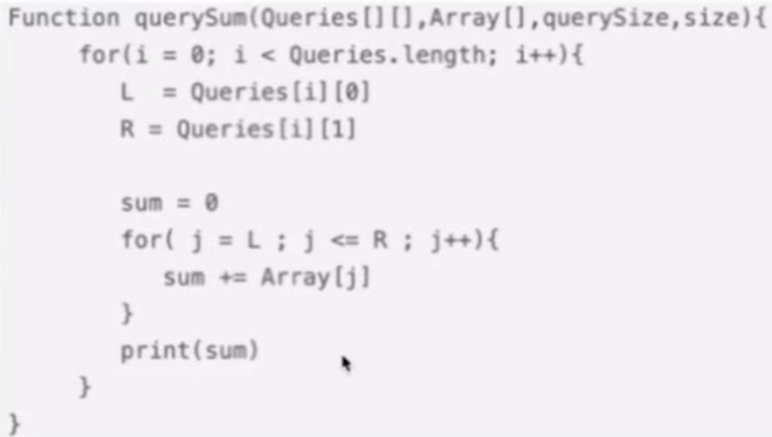

For every query travel from L to R.

T.C O (Q*N)

S.C O (1)

2D array representation for queries:

|  |  |  |
| --- | --- | --- |
| **INDEX** | **0th** | **1st** |
| **0th** | 4 | 8 |
| **1st** | 3 | 7 |
| **2nd** | 1 | 3 |
| **3rd** | 0 | 4 |
| **4th** | 7 | 7 |

For given constraint this brute force solution iterates up to 1010 iteration as per its time complexity which is O (Q*N) = Q*N = 105 * 105 = 1010

It will throw TLE error as online code editors expect to finish this solution within 107 to 108 iterations.

Note

For(i =1 to N){

For(j = 1 to N){

// Piece of code

}

}

Here to iterate both loop uses N variable in this case its T.C O (N2)

For(i =1 to N){

For(j = 1 to Q){

// Piece of code

}

}

Here to iterate 1st loop uses N variable and 2nd loop uses Q variable. Q and N are not same/related so in this case its T.C O (N * Q)

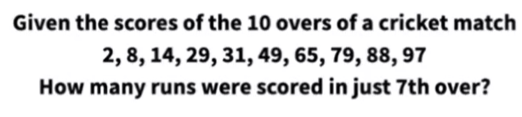

ANSWER: 65-49=16

After 6th over finished score is 49, after 7th over finished score is 65.

**PREFIX SUM:**

Cumulative sum array is called prefix sum array.

pf[i] = sum of all array elements from 0th till ith index.

e.g.,

arr [] = [2, 5, -1, 7, 1]

pf [] = [2, (5+2=7), (7-1=6), (6+7=13), (13+1=14)] = [2, 7, 6, 13, 14]

PREFIXSUM BRUTE FORCE APPROACH:

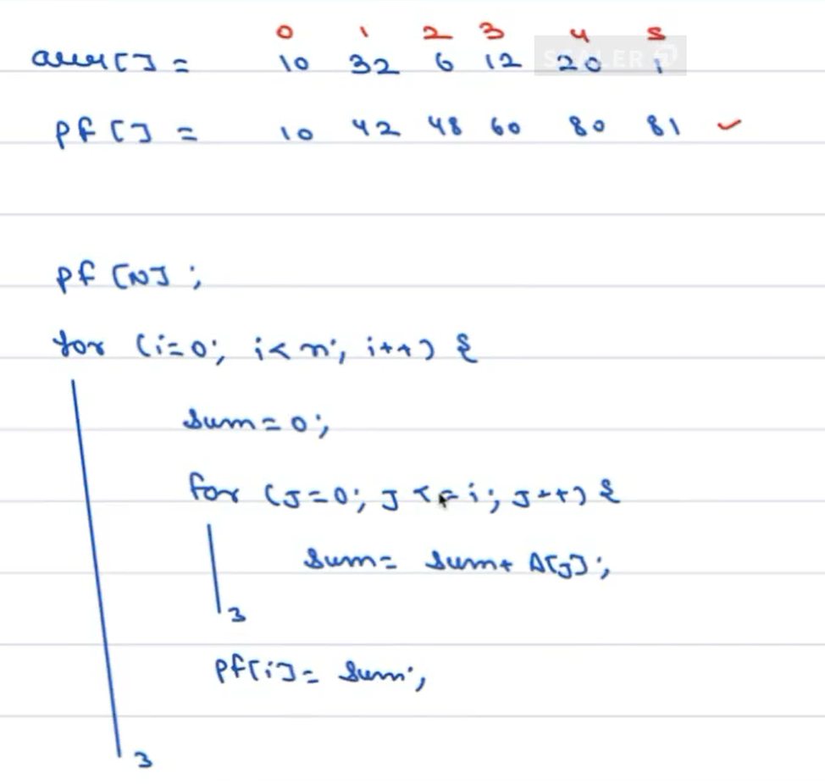

T. C O (N2)

PREFIXSUM OPTIMZED APPROACH:

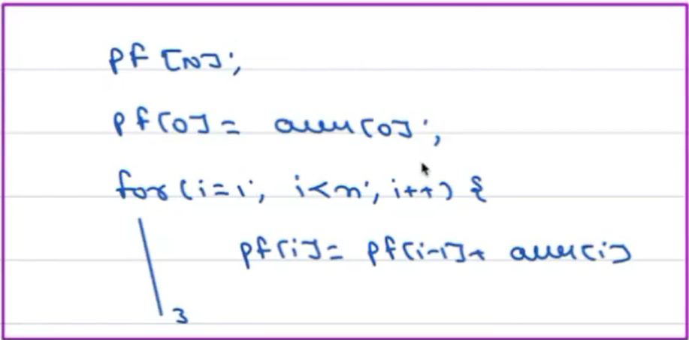

T.C O (N)

Q. Given N elements and Q Queries. For each query, calculate sum of all elements from L to R [0 based index].

A [] = [-3,6,2,4,5,2,8, -9,3,1]

Constrain:

1 <= N <= 105

1 <= Q <= 105

L R SUM

4 8 9

3 7 10

1 3 12

0 4 14

7 7 -9

OPTIMIZED APPROACH NOW

A [] = [-3,6,2,4,5,2,8, -9,3,1]

pf [] = [-3, 3, 5, 9, 14, 16, 24, 15, 18,19]

L R SUM

4 8 9 (from pf array 8th index – 3rd index which is 18-9=9)

3 7 10

1 3 12

0 4 14

7 7 -9

